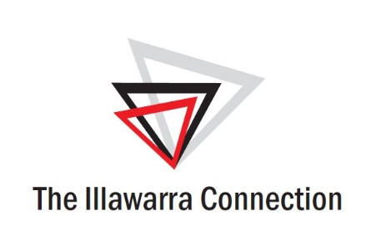

2023-24 EOI - Confidential Application
Surname:
First Name: |  |  | Preferred name:  (for name tags etc)
Date of birth: |  |  | Gender:
Organisation / employer:
Present job title:

Date commencement in this role:
Business address:

 |  |  |  |  | Postcode:
Telephone: | Business: |  |  |  | Mobile:
Business email:
Home address: |  |  |  |  | Postcode:
Home telephone:
Home email:

Employment / Experience:

Please provide a brief description of your current role, responsibilities, staff, etc.

Previous Employment in Reverse Chronological Order
Employer | Title / Responsibility | Dates
 |  | From | To

Education/ Training
(Reverse chronological order)
 | Institution | Location | Years
 |  |  | From | To | Qualifications & Specialisation
1.
2.
3.
4.
List any extra-curricular activities / leadership activities during education

Personal:
What are your reasons for nominating for the Leadership Illawarra Program?
What do you hope to gain?
What is your vision for the future of the Illawarra region?
What could your part be in this future?
How did you first hear about the Leadership Illawarra Program?:
CEO/Employer | Media | Past Participant | Word of mouth
Other (please specify)

Participant Commitment:
Time

The Leadership Illawarra program is a two-year commitment, commencing in February 2023 and concluding in December 2024. Essential elements include:

- Saturday workshops and Master Classes (up to 3 of each per year)
- Parliament House visits x 2. 2 days -Canberra. 1 day – Sydney
- Mentoring Program
- One core program/site visit per month (approximately 2 hours)

Participants are required to maintain a minimum attendance of 80% across all core program events. Failure to meet the 80% attendance requirement may result in consultation with the participant’s employer and / or possible discharge from the program.

Fees

The fee for the two-year Leadership Illawarra program is $4,000 per annum plus GST. This fee may be paid by the participant, or the employer.

Selection Criteria for Regional Development Australia Illawarra Candidate:

- Currently employed in a management or coordination capacity
- Demonstrated commitment to the Illawarra region and improvement of its human services capability.

Evidence:

- Commitment to develop your own capacity for leadership.

Evidence:

- Demonstrated ability to work as a member of a team.

Evidence:

Leadership Illawarra
Employer or Sponsor Agreement:
This candidate has my full support to participate in the Leadership
Illawarra Program. Yes No

I am aware of the time commitment, organisational and
financial contribution. Yes No

My organisation is available to participate by hosting a site visit during the program and supplying basic catering. Yes No

My organisation will provide access and support in the way
of guest speakers and information. Yes No

I am responsible for the payment of upfront fees for this Yes No
program ($4000 pa plus GST across 2 years)

Employer/CEO Name: |  | Position Title:
Signature: |  | Date:

Applicant Agreement:
I understand the goals and time commitment required of a participant in the Leadership Illawarra program. If selected I will devote the required time to attendance and personal involvement. I understand that I am committing to increased activity in the community upon graduation.

If selected I agree that any information and photographs throughout the program may be used for the program promotion and media releases, including the Leadership Illawarra program and associated websites.

Applicant’s Signature: |  | Date:

